FEASIBILITY ANALYSIS

NAME: K. Mohan Sai

**SURVEY**

The following is the pie chart of the responses for the feasibility of our “FACEPOLYGON” app.

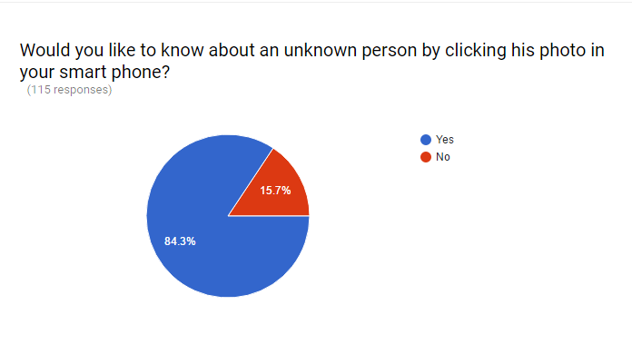

From the above pie chart 84.3% indicates about the people who are willing to know about the people who are willing to know the details of an unknown person and the remaining 15.7% said no to this.

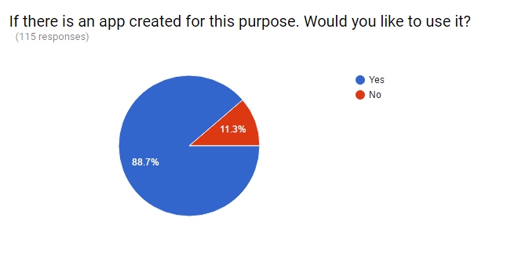

The above pie chart represents about the importance of our application.

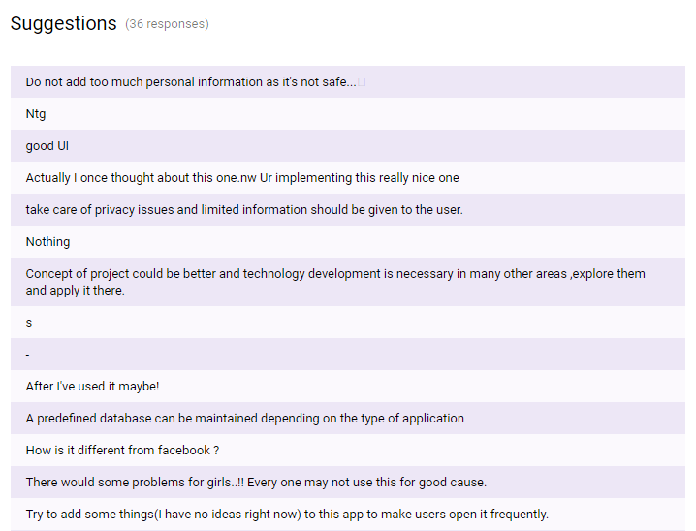

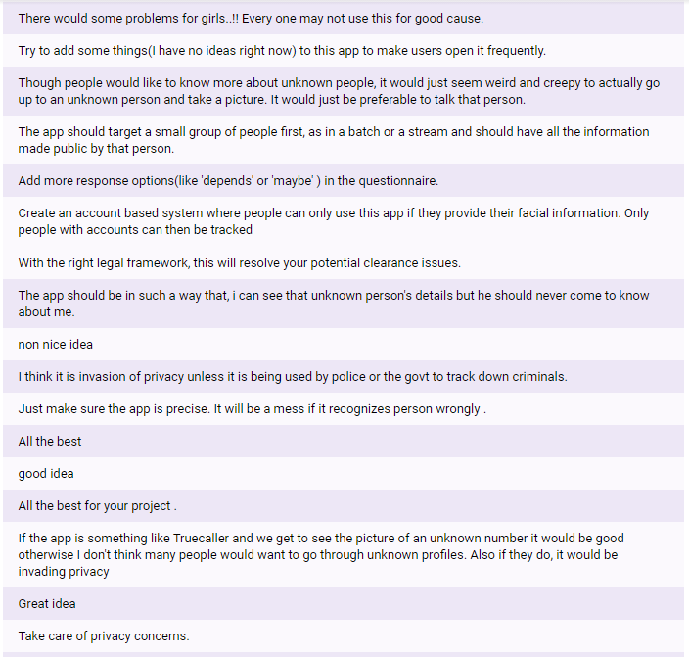

The above are the suggestions for “FACEPOLYGON” application. The study also resulted that the purpose and need for up to date generation.